./

DATASHEET

for Sunroof

Course Code: <CODE>



|  |  |  |  |  |  |
| --- | --- | --- | --- | --- | --- |
| **Ver. Rel. No.** | **Release Date** | **Prepared. By** | **Reviewed By** | **Approved By** | **Remarks/Revision Details** |
|  | 08-03-2021 | Ujjawal Kumar 99003745 |  |  |  |

# 

Table of Contents

Table of Figures 3

Table of Tables 4

ACTIVITY 1: SYSTEM/ SOFTWARE DEVELOPMENT 4

**INTRODUCTION** 4

**MY PRODUCT: “math operation calculator ”** 6

**SWOT ANALYSIS** 5

**REQUIREMENTS** 6

**DESIGN** 06

HIGH LEVEL DESIGN 06

LOW LEVEL DESIGN 07

**TEST PLANS** 08

**REFERENCES** 15

ACTIVITY 2: AGILE METHODOLOGY 15

**THEME** 15

**EPIC** 15

**USER STORY** 16

**REFERENCES** 17

APPENDIX: 17

1. INTRODUCTION:

A sunroof is a movable panel that opens to uncover a window in an automobile roof, allowing light and/or fresh air to enter the passenger compartment. Sunroofs can be manually operated or motor driven, and are available in many shapes, sizes and styles. While the term sunroof is now used generically to describe any glass panel in the roof, the term "moonroof" was historically used to describe stationary glass panes rigidly mounted in the roof panel over the passenger compartment. A moonroof has a glass panel that is transparent and usually tinted. Previous terms include Sunshine Roof, Sliding Head and Sliding Roof.

1. RESEARCH:

The sunroof includes one of the motion mechanisms that we find in vehicle bodies. The design and manufacturing of their electric actuators enable us to offer a precise motion to open and close these systems, which are being increasingly added to more and more models.

There are different type of sunroof available in the industry. The examples of sunroof types are as follows:

* 1. Removable sunroofs**:** The first models with sunroofs used this simple system. It involves a cover that has hinges on its rear side which allow for manual opening as if it were a “trap door”. It has a full (limited by a stop) or adjustable range of motion.
  2. Sliding sunroofs: These are the models currently in use and incorporate electric actuators for actuation of the system. When the roof opens, it slides underneath the body (though it may also do so over it). Within this model, we can find many options. Some are as follow:
     1. Glass or metal louvered sunroof system:  It is an unusual system, and works like a curtain. When opening the roof, the louvers are superimposed one over the other.
     2. Folding fabric sunroof: The system is similar to the example above but using fabric. They are midway between convertibles and conventional sunroofs.
     3. Modular sunroof:
     4. Moonroof: composed of an electric actuation mechanism, a sunshade and a glass cover.
     5. Spoiler Sunroof: In this the cover is tilted over the body
     6. Multi-panel or panoramic systems.

2.3 My Feature:

Here we are taking GMC Sierra Sunroof which is a type of Spoiler Sunroof.

2.3.1 Working of my Feature:

The sunroof operates when the ignition is on or in ACC/ ACCESSORY, or when Retained Accessory Power (RAP) is active.

Slide Switch to Open:

1: To express-open the sunroof, fully press and release (1).

2: Press and release (1) again to stop the movement.

Slide Switch to Close:

1: To express-close the sunroof, fully press and release K (1).

2: Press and release K (1) again to stop the movement.

Tilt Switch Vent:

1**:** From the closed position, press (2) to vent the sunroof.

2: Press K (2) to close the vent.

When the sunroof is opened, an air deflector will automatically raise. The air deflector will retract when the sunroof is closed.

The sunroof also has a sunshade, which can be pulled forward to block sun rays. The sunshade must be opened and closed manually.

2.3.2 Automatic Reversal System

The sunroof has an automatic reversal system that is only active when the sunroof is operated in express-close mode. If an object is in the path while express-closing, the reversal system will detect an object, stop, and open the sunroof slightly. If frost or other conditions prevent closing, override the feature by closing the sunroof in manual mode. To stop movement, release K (1). Dirt and debris may collect on the sunroof seal or in the track. This could cause an issue with sunroof operation or noise. It could also plug the water drainage system. Periodically open the sunroof and remove any obstacles or loose debris. Wipe the sunroof seal and roof sealing area using a clean cloth, mild soap, and water. Do not remove grease from the sunroof tracks. If water is seen dripping into the water drainage system, this is normal.

2.4 Requirements:

2.4.1 High Level Requirements:

|  |  |
| --- | --- |
| Requirements ID | Requirement |
| HLR_374501 | Opening/Closing Sunroof |
| HLR_374502 | Tilting Sunroof |

2.4.2 Low Level Requirements:

|  |  |
| --- | --- |
| Requirements ID | Requirement |
| LLR_374501 | Switch Control |
| LLR_374502 | Operating motor used for sunroof panels |

* 1. INPUTS

2.5.1 Switches

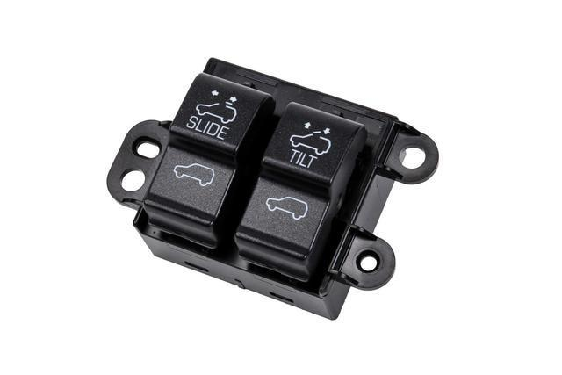

Fig1: Switch

* + 1. Sensor:
       1. Honeywell’s Linear Hall-effect Sensor ICs: SS490 Series

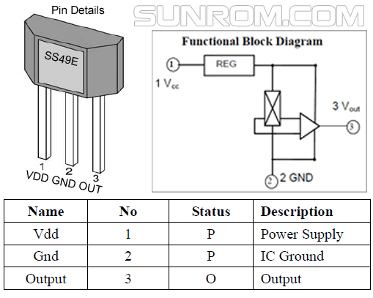

Fig2: Honeywell’s Linear Hall-effect Sensor pins

|  |  |  |  |
| --- | --- | --- | --- |
| **Characteristic** | **Min.** | **Max.** | **Unit** |
| Supply current | - | 8.7 | mA |
| Output Current | 0.6 | 1.5 | mA |
| Supply voltage | -0.5 | 11 | V |
| Output voltage | -0.5 | 11 | V |
| Operating Temp | -40 | 150 | C |
| Linearity | 0 | -1.5 | % of span |
| Sensitivity | 4.6 | 5.4 | mV/Gauss |

Table1: Honeywell’s Linear Hall-effect Sensor ICs Specification

**Characteristics (V/Gauss)**

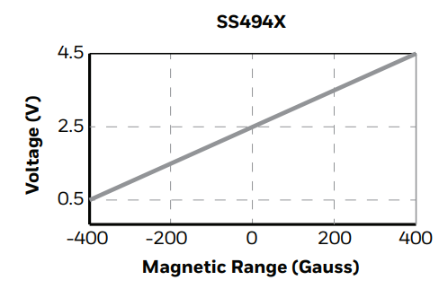

Fig3: (V/Gauss) Characteristics

Application:

* Basic current sensing for motor load monitoring, detection
* Handlebar/throttle position sensing in e-bikes and scooters
* Current sensing in appliances
* Speed adjustment trigger in tools and appliances
  + - 1. DRV5055XX Ratio Metric Linear Hall Effect Sensor

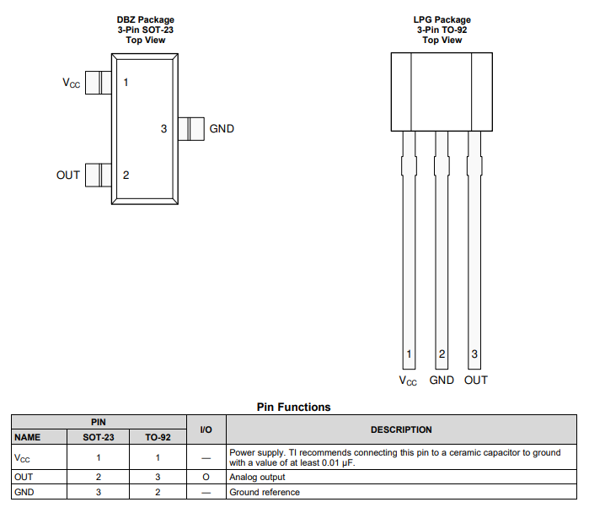

Fig4: Pin Configuration

|  |  |  |  |
| --- | --- | --- | --- |
| Parameter | MIN | MAX | UNIT |
| Supply Voltage | 3 | 5.5 | V |
| Supply Current | - | 10 | mA |
| Output Current | -1 | 1 | mA |
| Operating Temperature | -40 | 125 | C |
| Sensitivity | 95 | 100 | mV/mT |
| Linear Magnetic Sensing | ±21 | ±169 | mT |

Table2: DRV5055 Ratio Metric Linear Hall Effect Sensor Specification

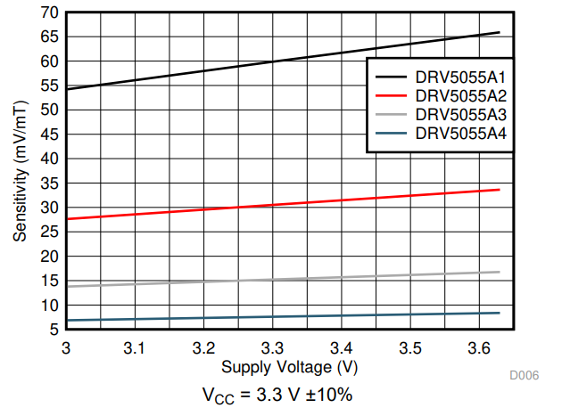

Fig5: Sensitivity vs Supply Voltage

Application:

• Precise Position Sensing

• Industrial Automation and Robotics

• Gamepads, Pedals, Keyboards, Triggers

• Current Sensing

* + - 1. Linear Output Magnetic Field Sensor AD22151:

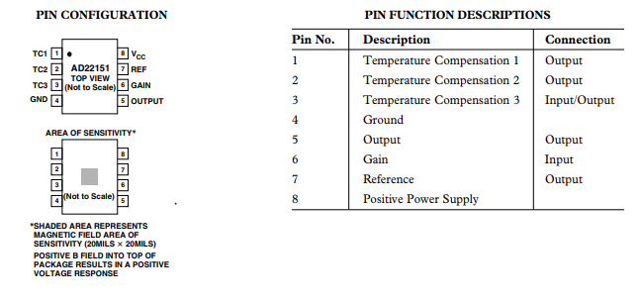

Fig6: Pin Configuration

|  |  |  |  |
| --- | --- | --- | --- |
| Parameter | MIN | MAX | UNIT |
| Supply Voltage | 4.5 | 6.0 | V |
| Supply Current | - | 10 | mA |
| Operating Temperature | -40 | +150 | C |
| Nonlinearity |  | 0.1 | %FS |

Table 3: Sensor Specification

ss

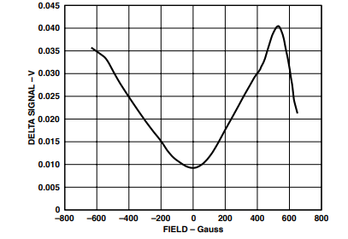

Fig 7: Characteristics

Application:

* Anti-Pinch control
* Throttle Position Sensing
* Pedal Position Sensing
* Suspension Position Sensing
* Valve Position Sensing
  + 1. OUTPUT:

2.5.3.1 Motor output**:**

For running the motor first, we need half bridge for running the sunroof motor.

Here I’m using **NovalithIC™ BTN8982TA** Integrated high current half-bridge motor drivers.

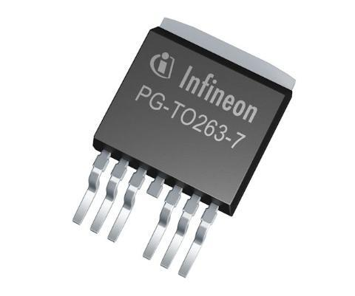

Fig8: NovalithIC™ BTN8982TA

|  |  |  |  |
| --- | --- | --- | --- |
| Parameter | Min. | Max. | Unit |
| Input Voltage | -0.3 | 5.3 | V |
| Output Voltage | -0.3 | 40 | V |
| Current | - | 3.3 | mA |
| Junction Temperature | -40 | 150 | C |

Table 4: Motor Driver Specification

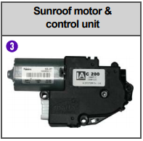

Fig9: sunroof motor control unit

|  |  |  |  |
| --- | --- | --- | --- |
| Parameter | Min | Max | Unit |
| Operating voltage | 9 | 16 | V |
| Operating current | - | 6 | A |
| At no load | - | 3 | A |
| Roof motor operating speed |  | 1.4 ± 0.5 sec./100 mm |  |

Table5: Motor specification

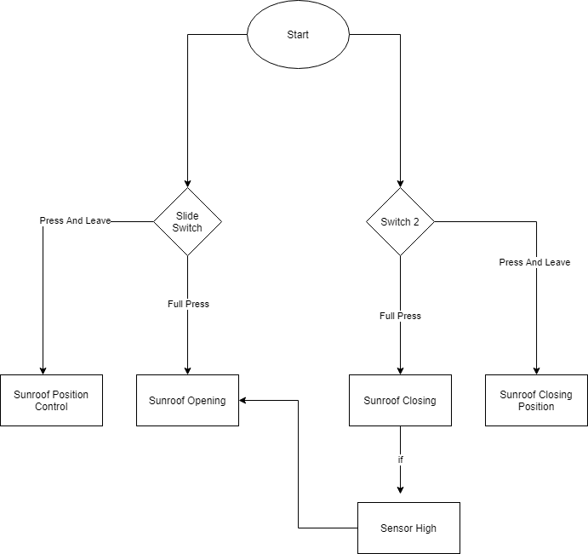

1. SWOT Analysis

|  |  |
| --- | --- |
| Strength   1. Tilting Roof 2. Anti-Pinch Panel | Weakness   1. Dirt may seal the Sunroof 2. sunroof operation or noise 3. Sometime manual Operation needed |
| Opportunities   1. Fully manual sunroof Operation if stuck | Threats   1. Stuck when motor is jammed 2. Sometime water seepage if problem in seal defected |

Final Evolution:

|  |  |
| --- | --- |
| Before   1. No sensor used 2. Roof control is on Knob system 3. No information of motor we used | After   1. Use of hall sensor for object detection 2. Roof control is on Dual switch system 3. Research on motor is done |

1. Test Plan:

|  |  |  |  |  |  |
| --- | --- | --- | --- | --- | --- |
| Test ID | Description | Expected Input | Expected Output | Actual Output | Type of Test |
| HLT_374501 | Opening the Sunroof | Press the Switch | Sunroof should be open | Sunroof opening | Requirement Based |
| HLT_374502 | Holding the position | Again press the same switch | Sunroof should be stop when the switch is pressed | Sunroof is stopped at a point | Requirement Based |
| HLT_374503 | Again Opening the Sunroof | Again press the same switch | Sunroof should be stop when the switch is pressed | Sunroof opening | Requirement Based |
| HLT_374504 | Holding the position | Again press the same switch | Sunroof should be stop when the switch is pressed | Sunroof is stopped at a point | Requirement Based |
| HLT_374505 | Closing the Sunroof | Press the Second Switch | Sunroof should start closing when the switch is pressed | Sunroof opening | Requirement Based |
| HLT_374505 | Holding the position | Again press the same second switch | Sunroof should be stop when the switch is pressed | Sunroof is stopped at a point | Requirement Based |